What is a functor in Haskell?

Functor in Haskell is **a typeclass that provides two methods – fmap and (<$) – for structure-preserving transformations**. To implement a Functor instance for a data type, you need to provide a type-specific implementation of fmap – the function we already covered.

Is maybe a functor Haskell?

**Another simple example of a functor is the Maybe type**. This object can contain a value of a particular type as Just , or it is Nothing (like a null value).

Is Io a functor Haskell?

**IO is a functor**, and more specifically an instance of Applicative , that provides means to modify the value produced by an I/O action in spite of its indeterminacy.

What are functors used for?

A C++ functor (function object) is a class or struct object that can be called like a function. It overloads the function-call operator () and **allows us to use an object like a function**.

Is monad a functor?

A functor is a data type that implements the Functor typeclass. An applicative is a data type that implements the Applicative typeclass. **A monad is a data type that implements the Monad typeclass**. A Maybe implements all three, so it is a functor, an applicative, and a monad.

**Functors, Applicatives, And Monads In Pictures**

Here's a simple value: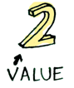

And we know how to apply a function to this value:

Simple enough. Lets extend this by saying that any value can be in a context. For now you can think of a context as a box that you can put a value in:

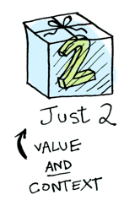

Now when you apply a function to this value, you'll get different results **depending on the context**. This is the idea that Functors, Applicatives, Monads, Arrows etc are all based on. The Maybe data type defines two related contexts:

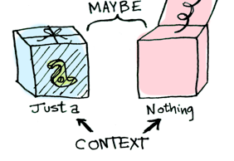

data Maybe a = Nothing | Just a

In a second we'll see how function application is different when something is a Just a versus a Nothing. First let's talk about Functors!

## Functors

When a value is wrapped in a context, you can't apply a normal function to it:

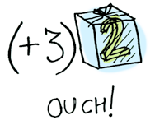

This is where fmap comes in. fmap is from the street, fmap is hip to contexts. fmap knows how to apply functions to values that are wrapped in a context. For example, suppose you want to apply (+3) to Just 2. Use fmap:

> fmap (+3) (Just 2)

Just 5

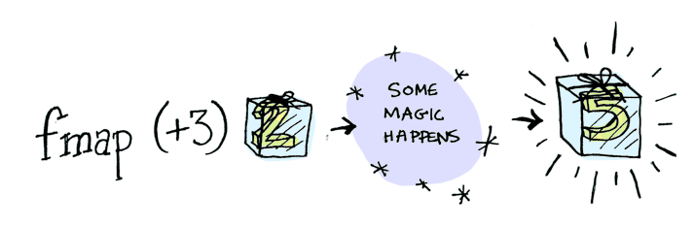

**Bam!** fmap shows us how it's done! But how does fmap know how to apply the function?

## Just what is a Functor, really?

Functor is a [typeclass](http://learnyouahaskell.com/types-and-typeclasses#typeclasses-101). Here's the definition:

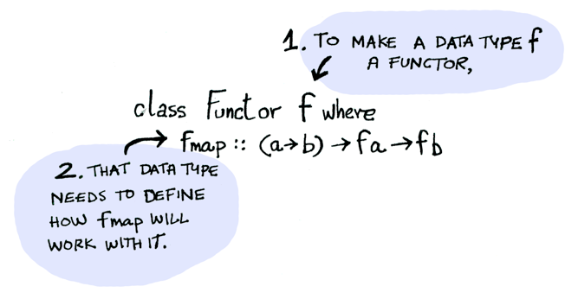

A Functor is any data type that defines how fmap applies to it. Here's how fmap works:

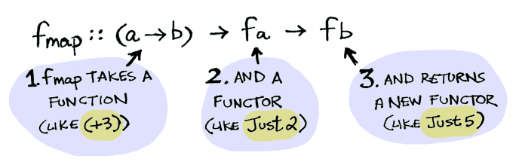

So we can do this:

> fmap (+3) (Just 2)

Just 5

And fmap magically applies this function, because Maybe is a Functor. It specifies how fmap applies to Justs and Nothings:

instance Functor Maybe where

fmap func (Just val) = Just (func val)

fmap func Nothing = Nothing

Here's what is happening behind the scenes when we write fmap (+3) (Just 2):

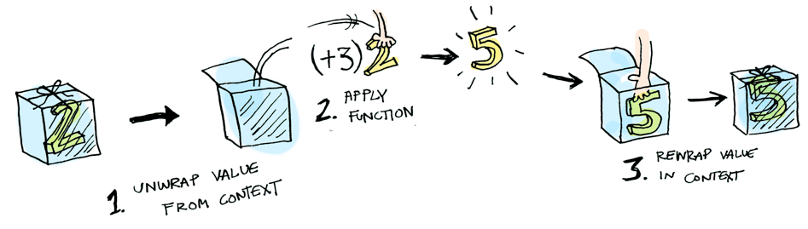

So then you're like, alright fmap, please apply (+3) to a Nothing?

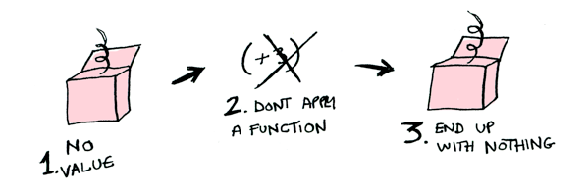

> fmap (+3) Nothing

Nothing

i.e:

Just (+3) <*> Just 2 == Just 5

Using <*> can lead to some interesting situations. For example:

> [(*2), (+3)] <*> [1, 2, 3]

[2, 4, 6, 4, 5, 6]

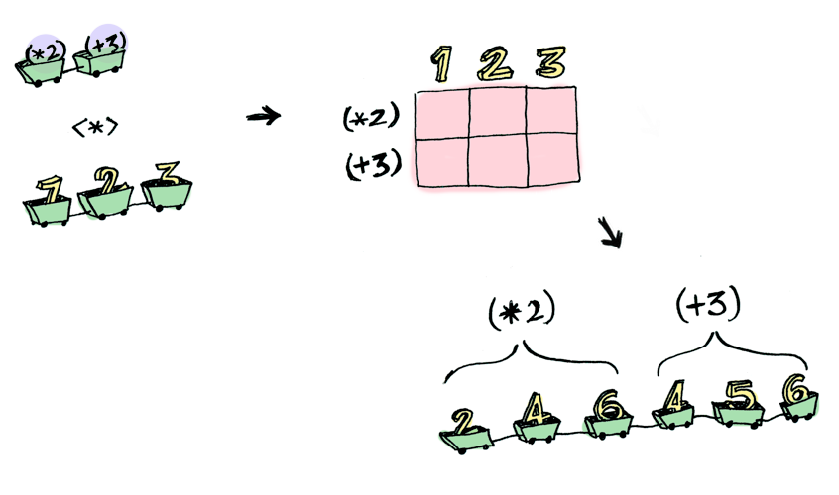

Here's something you can do with Applicatives that you can't do with Functors. How do you apply a function that takes two arguments to two wrapped values?

> (+) <$> (Just 5)

Just (+5)

> Just (+5) <$> (Just 4)

ERROR ??? WHAT DOES THIS EVEN MEAN WHY IS THE FUNCTION WRAPPED IN A JUST

Applicatives:

> (+) <$> (Just 5)

Just (+5)

> Just (+5) <*> (Just 3)

Just 8

Applicative pushes Functor aside. "Big boys can use functions with any number of arguments," it says. "Armed <$> and <*>, I can take any function that expects any number of unwrapped values. Then I pass it all wrapped values, and I get a wrapped value out! AHAHAHAHAH!"

> (*) <$> Just 5 <*> Just 3

Just 15

And hey! There's a function called liftA2 that does the same thing:

> liftA2 (*) (Just 5) (Just 3)

Just 15

## Monads

How to learn about Monads:

Monads add a new twist.

Functors apply a function to a wrapped value:

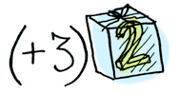

Applicatives apply a wrapped function to a wrapped value:

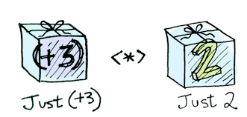

Monads apply a function **that returns a wrapped value** to a wrapped value. Monads have a function >>= (pronounced "bind") to do this.

Let's see an example. Good ol' Maybe is a monad:



Suppose half is a function that only works on even numbers:

half x = if even x

then Just (x `div` 2)

else Nothing

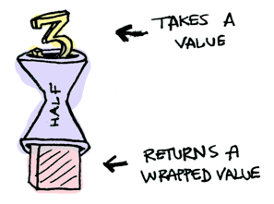

What if we feed it a wrapped value?

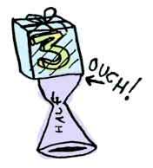

We need to use >>= to shove our wrapped value into the function. Here's a photo of >>=:

Here's how it works:

> Just 3 >>= half

Nothing

> Just 4 >>= half

Just 2

> Nothing >>= half

Nothing

What's happening inside? Monad is another typeclass. Here's a partial definition:

class Monad m where

(>>=) :: m a -> (a -> m b) -> m b

Where >>= is:

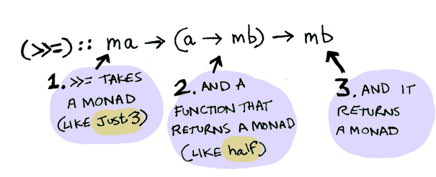

So Maybe is a Monad:

instance Monad Maybe where

Nothing >>= func = Nothing

Just val >>= func = func val

Here it is in action with a Just 3!

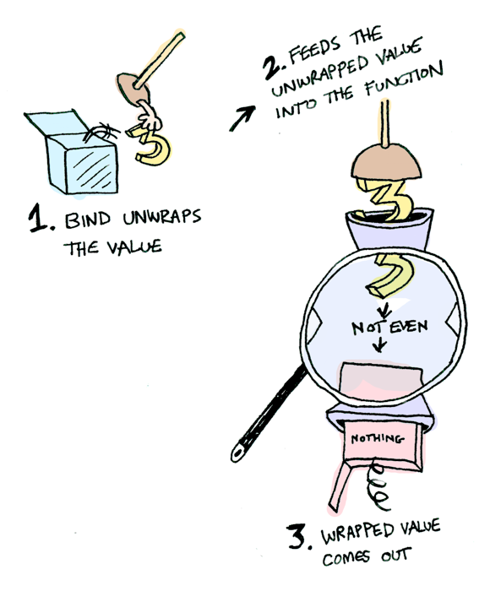

And if you pass in a Nothing it's even simpler:

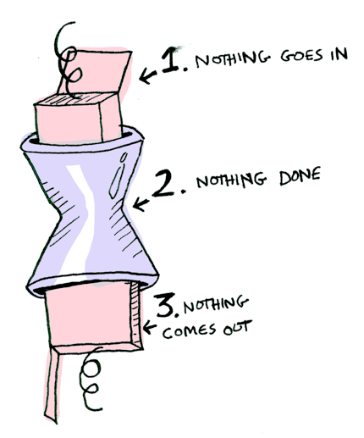

You can also chain these calls:

> Just 20 >>= half >>= half >>= half

Nothing

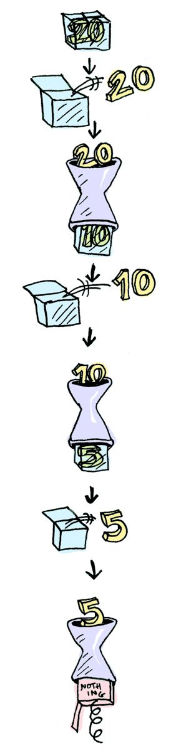

Cool stuff! So now we know that Maybe is a Functor, an Applicative, and a Monad.

Now let's mosey on over to another example: the IO monad:



Specifically three functions. getLine takes no arguments and gets user input:



getLine :: IO String

readFile takes a string (a filename) and returns that file's contents:



readFile :: FilePath -> IO String

putStrLn takes a string and prints it:



putStrLn :: String -> IO ()

All three functions take a regular value (or no value) and return a wrapped value. We can chain all of these using >>=!

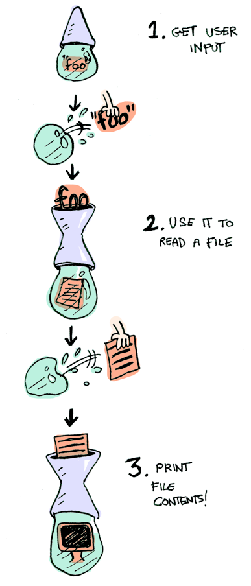

getLine >>= readFile >>= putStrLn

Aw yeah! Front row seats to the monad show!

Haskell also provides us with some syntactical sugar for monads, called do notation:

foo = do

filename <- getLine

contents <- readFile filename

putStrLn contents

## Conclusion

1. A functor is a data type that implements the Functor typeclass.
2. An applicative is a data type that implements the Applicative typeclass.
3. A monad is a data type that implements the Monad typeclass.
4. A Maybe implements all three, so it is a functor, an applicative, and a monad.

What is the difference between the three?

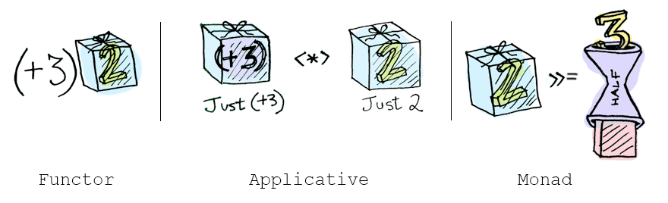

* **functors:** you apply a function to a wrapped value using fmap or <$>
* **applicatives:** you apply a wrapped function to a wrapped value using <*> or liftA
* **monads:** you apply a function that returns a wrapped value, to a wrapped value using >>= or liftM